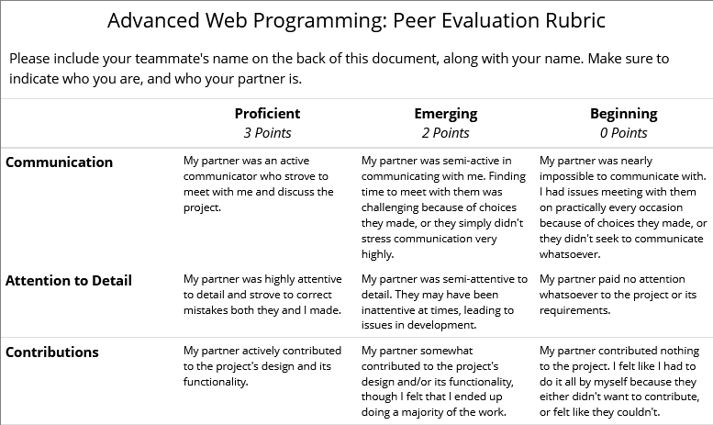

Name: Joel Lopez Villarreal

Partner’s name: Adrian Morales

Communication: 2

Attention to Detail: 2

Contributions: 2